**Assignment 03 CCN Theory**

**Spring 2025**

Submitted by: **Mohsin Sajjad**

Registration No: **22pwsce2149**

Class Section: **A**

“On my honor, as student of University of Engineering and Technology, I have neither given nor received unauthorized assistance on this academic work.”

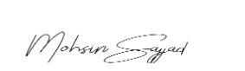

Student Signature: ______________

Submitted to:

**Engr. Ihsan ul haq**

Month Day, Year (22 05, 2025)

Department of Computer Systems Engineering

University of Engineering and Technology, Peshawar

Assignment Date: 21st May, 2025

***Strict Deadline*** ***26th May 2025 (2 pm, Location CR: 6)***, After the Deadline None of the Assignment will be accepted.

**Note: visit the following site:** [**https://tryhackme.com/room/introtonetworking**](https://tryhackme.com/room/introtonetworking) **After completing the above tasks, answer the following questions and submit before the deadline preferably during the Class.**

**Note: Marking will be based on the Correct Answers expected on the site ONLY.**

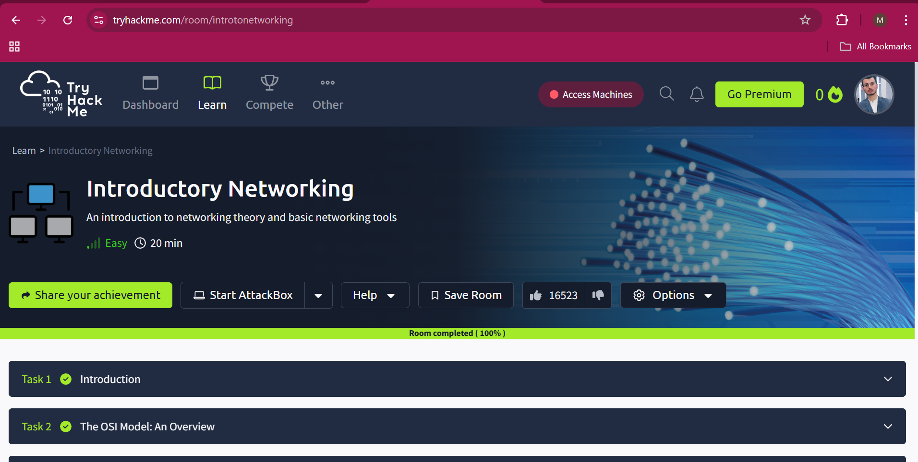

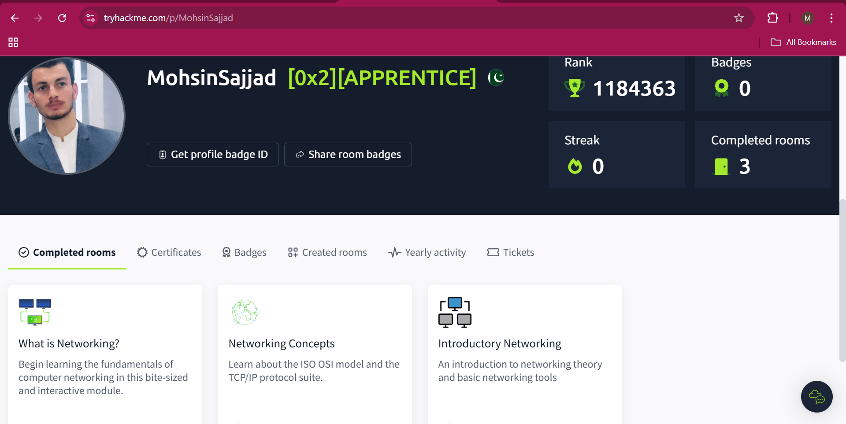

1. Which layer would choose to send data over TCP or UDP? Answer with the number of the layer: e.g. if the answer is "the application layer", then you should enter "7".

**Answer:**

4

1. Which layer checks received information to make sure that it hasn't been corrupted? Answer with the number of the layer: e.g. if the answer is "the application layer", then you would enter "7".

**Answer:**  
2

1. In which layer would data be formatted in preparation for transmission? Answer with the number of the layer: e.g. if the answer is "the application layer", then you would enter "7".

**Answer:**

2

1. Which layer transmits and receives data? Answer with the number of the layer: e.g. if the answer is "the application layer", then you would enter "7".

**Answer:**

**1**

1. Which layer encrypts, compresses, or otherwise transforms the initial data to give it a standardized format? Answer with the number of the layer: e.g. if the answer is "the application layer", then you would enter "7".

**Answer:**

**6**

1. Which layer tracks communication between the host and receiving computers? Answer with the number of the layer: e.g. if the answer is "the application layer", then you would enter "7".

**Answer:**

**5**

1. Which layer handles logical addressing? Answer with the number of the layer: e.g. if the answer is "the application layer", then you would enter "7".

**Answer:**

**3**

1. How would you refer to data at layer 2 of the encapsulation process (with the OSI model)?

**Answer:  
Frames**

1. How would you refer to data at layer 4 of the encapsulation process (with the OSI model), if the UDP protocol has been selected?

**Answer:  
Packet**

1. Which is the only layer of the OSI model to add a *trailer* during encapsulation?

**Answer:**

**Data-link**

1. Which layer of the TCP/IP model covers the functionality of the Transport layer of the OSI model **(Full Name)**?

**Answer:**

**Tansport**

1. Which layer of the TCP/IP model covers the functionality of the Session layer of the OSI model **(Full Name)**?

**Answer:**

**Application**

1. What kind of protocol is TCP?

**Answer:**

**Connection-based**

1. What switch in ping lets you change the interval of sent ping requests?

**Answer:**

**-i**

1. What switch would you use to specify an interface when using Traceroute?

**Answer:**

**-i**

1. Use whois and find the registrant postal code for facebook.com?

**Answer:**

**94025**